REST API APPLICATION FOR MANAGING USER POSTS

Hi , This Application is created by Yash Raghava.

You can use this application to access User Details and Posts created by them through REST API.

The Application uses SpringBoot Features like Customized Exception Handling across the Entire Application, HATEOAS , Version Control and Static Filtering .

Various Dependencies used in this project are –

Spring Boot Starter Web, Spring Boot Starter Validation Spring Boot Starter Data Jpa

I have used H2 InMemory Database to connect with the application.

APPLICATION SCREENSHOT

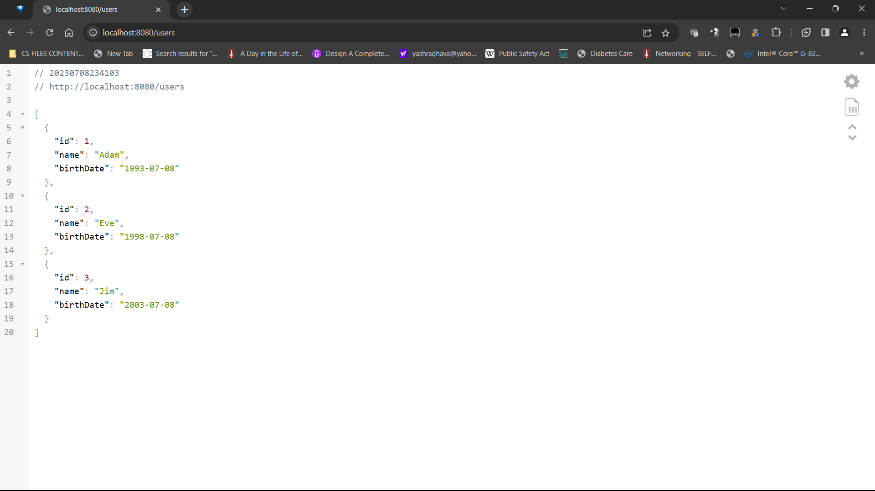

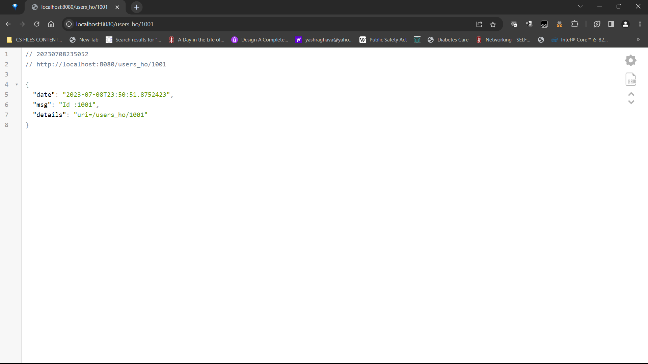

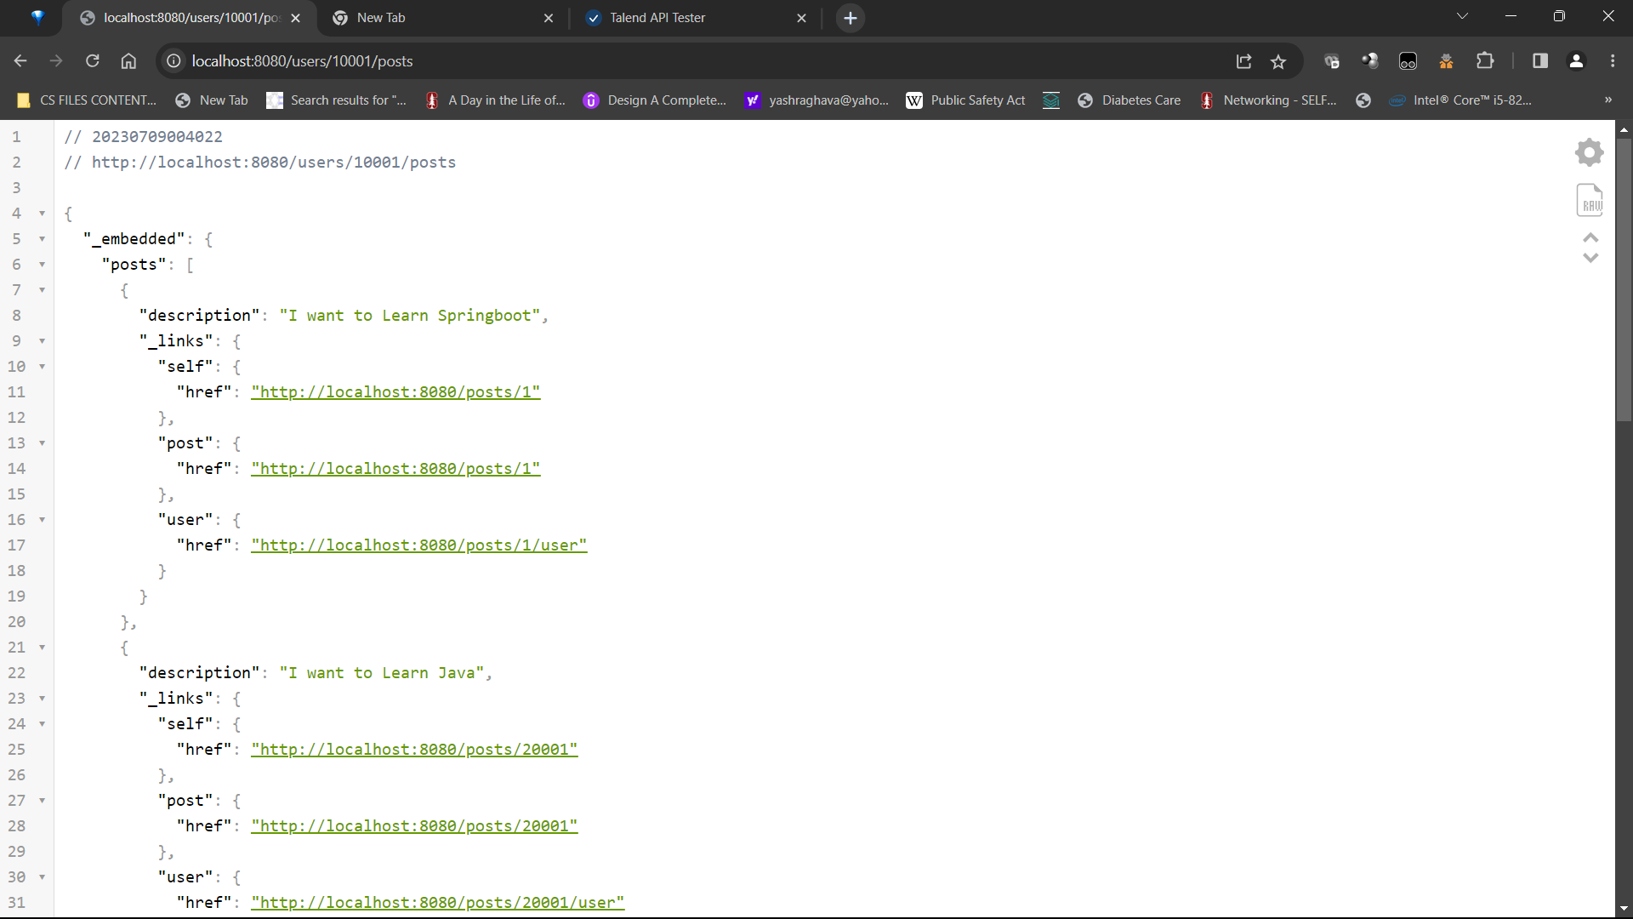

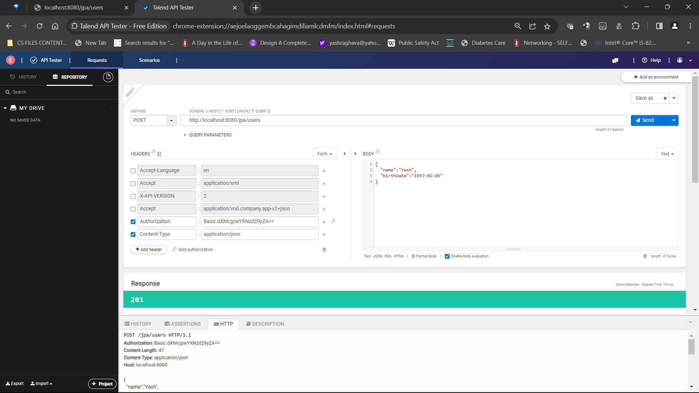

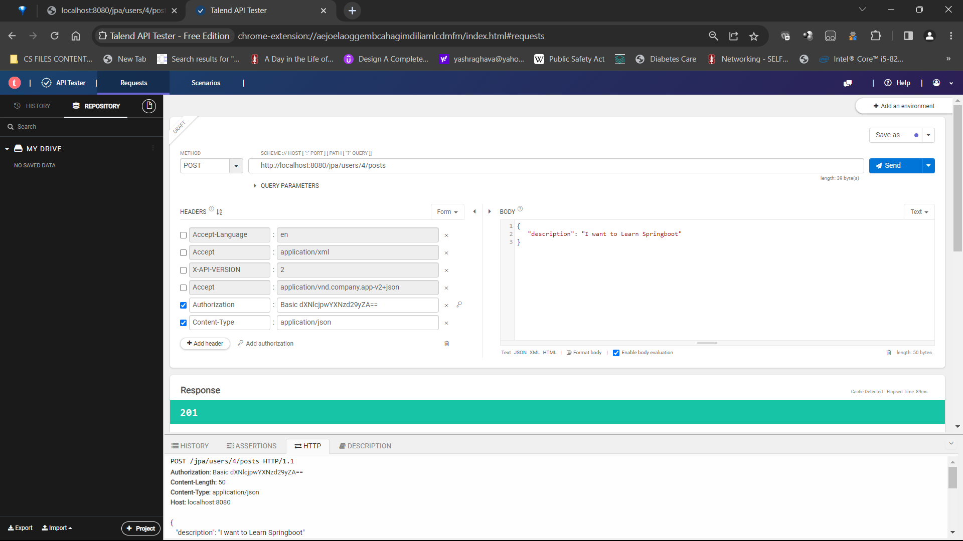

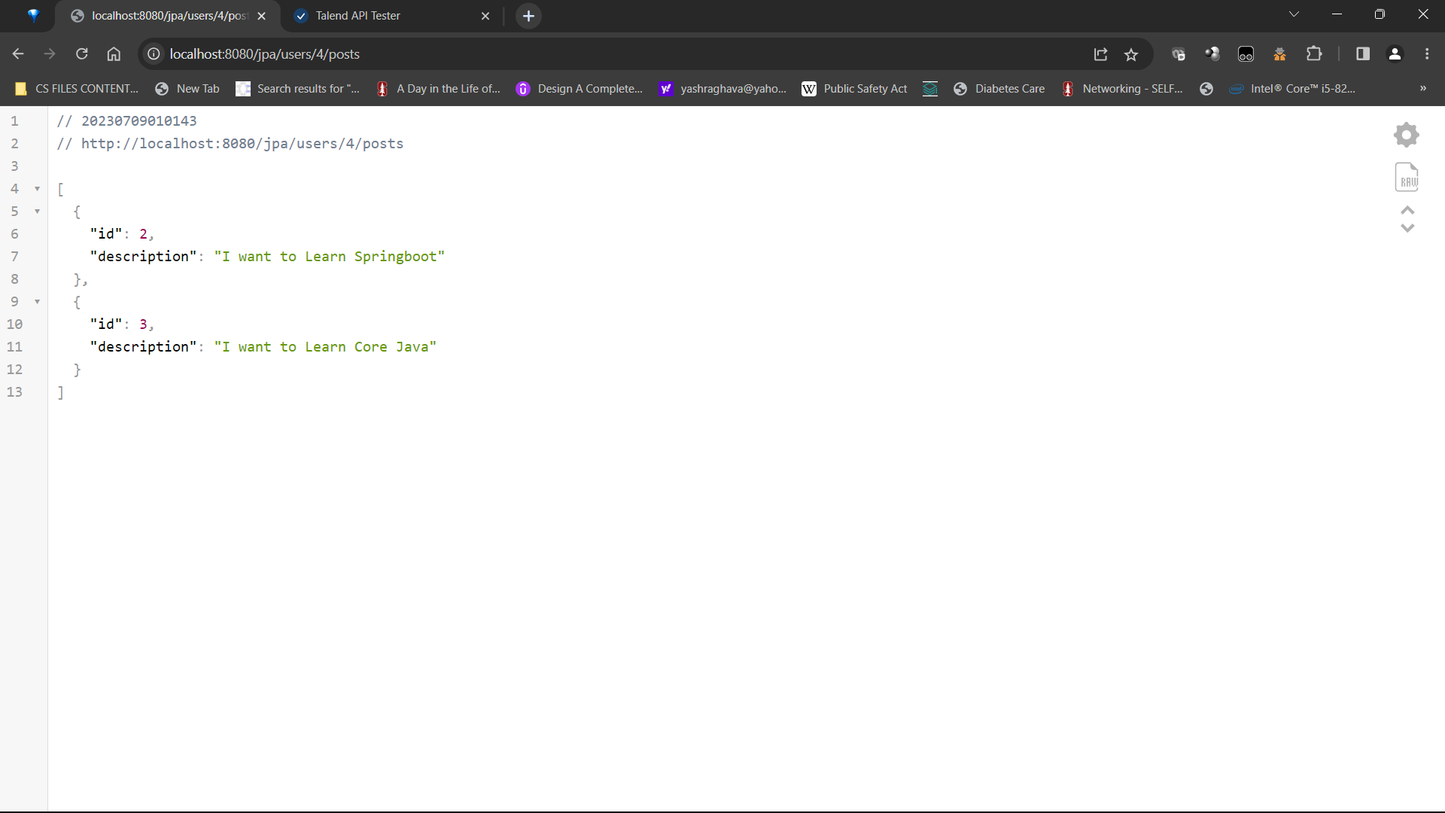

HAL SCREENSHOT

